CHAPTER 2
SOFTWARE REQUIREMENTS SPECIFICATIONS
(Overview of stage I)

2.1 Introduction
The software requirements specifications (SRS) produced at culmination of analysis task. The function and performance is refined by establishing a complete information description, detailed description, design constraints and other information pertinent to requirements.

2.2 Overall Description
2.2.1 Product Functions
- Browsing for the test file.
- Running the selected test file.
- Showing the progress of the running of the test file.
- Showing the statistics of the test cases.
- Reporting the results to the mailing list.

The gkUnit tests one test case at a time as it is a unit testing framework. The test file is selected by browsing the appropriate folders. If test throws an Assert Exception, gkUnit reports the failure due to failed assertion. If the test throws any exception then gkUnit reports the test failure due to exception. If any part of the code has not been implemented in the web application then the test shows the xmlrpclib fault and it is reported accordingly. If nothing of this occurs and test case runs properly then the test case is passed and the result is indicated on the screen. The counters indicates total number test cases run, number of test cases which are passed, number of failures in the test case, number of errors in the test case and number of remaining test cases to run while the test is in progress. The developer is able to report the result of the test by clicking on the Report button in the user interface.

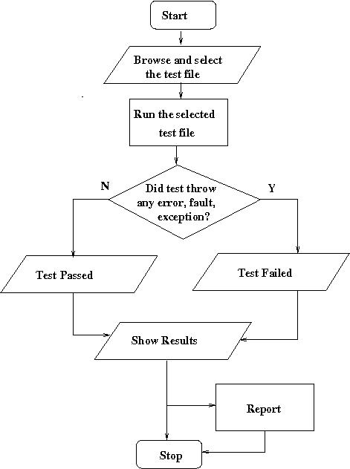

Figure 2.1: Flowchart

2.2.2 Operating Environment
Software Requirement
To run the test cases with gkUnit the GNUKhata web application should be installed.
Operating System: Linux operating systems.
Language of coding: Python
Software environment: Python 2.7, Pylons0.9.7.

Hardware Requirement
Minimum 1 GB RAM
Minimum 40 GB Hard Disk
CPU: 1.8 GHz or above

2.2.3 Design and implementation constraints
Hardware Limitations:
Timing Constraints: At the max 1 minute for each test
Memory Requirements: Minimum 1 GB RAM
Software Limitations:
Parallel operations: GNUKhata Server must be On
Databases: Postgresql 8.4
Programming Language: Python 2.7

2.2.4 Assumptions and dependencies
Assumptions:
- The GNUKhata web application is running and working on the system on which tests will be run.
- We may or may not have entire internal knowledge of GNUKhata Web Application.
Dependencies:
- The correct ongoing version of the GNUKhata environment must be installed on the system.
- Correct version of python and pylons environment should be installed on the system.
- Test cases must be ready to run in the gkUnit framework.

2.2.5 Overview of data requirements
To run the project we require the test cases and for writing effective test cases we require to understand the functionality of the web application.
Data requirements for testing the web application we need the APIs. For writing the test cases we have idea of the API's functionality or the API itself to understand its function. When we know what it does, effective test case is written to check if the functionality is achieved and if the API behaves or will behave properly. We provide sample data in a test case to check if the inputs are given and accepted correctly and assertions are checked along with the expected result of the function sin the APIs.

2.3 System Features

Features

1. Easy to use user interface:
The Automated Unit Testing Framework is called as “gkUnit” which is our final product for GNUKhata Developers. The gkUnit is an Automated Unit Testing Framework. The gkUnit has a very simple user friendly GUI. A Framework or a Window is displayed as Developer gives command on terminal to start it.
The frame allows developers to browse the test files with the help of browse button. When the test file is selected, the test is loaded and run automatically. Once the test case is run properly, its result with or without errors, failures will be visible on the screen. If there are errors or failures the detailed description is displayed when the developer clicks on the particular error of failure.
2. Display of Results
The result of each test file is displayed in test results area.
3. Reporting to the mailing list
Developer can report the results of the tests to the mailing list.
Testing of APIs includes each function and each class undergoing testing. The each piece of API code is checked and tested. Each API generally has setUp and tearDown methods which connects to the server of GNUKhata and disconnects the connection after testing is undergone, respectively. Each function generally undergoes testing for connection, for right data input, for wrong data input, for type error and/or any specific test related to method written inside API.

The following table shows the general test case involved in the project:

Sr. No | Name of test | Description of test
1 | Testing for type error | This test is written to check whether the return type of a particular method is proper or not.
2 | Testing for right input | This test is written to check whether we are getting the expected output when correct input is provided.
3 | Testing for wrong input | This test is written to throw out the exceptions or errors when wrong input is provided.
4 | Testing methods for multiple times | This test checks the response of API methods if it is executed multiple times

Table 2.1: Test Cases

2.3.1 Description and priority

Sr. No. | Activity | Description | Priority | Scale
1 | Load | View the file dialog to select the file to show in Transfer area | High | 5/6
2 | Run | View the file dialog to select the file to run it | High | 6/6
3 | Result Area | Show the errors, failures or faults if any occurs and show the result of test case | High | 6/6
4 | Transfer Area | Show the contents of selected file | High | 5/6
5 | Help | Give the official web site address of GNUKhata | Medium | 4/6
6 | About | Open a window displaying information about product gkUnit | Low | 2/6

Table 2.2: Description and priority table
Priority Scale

Low: 1, 2 Medium: 3, 4 High: 5, 6

2.3.2 FUNCTIONAL REQUIREMENTS
The main functional requirement is that the GUI of the gkUnit should work properly. It should not allow any other file type other than *.py to be opened. As it is a specific product to test web application GNUKhata only, it is assumed that the user or developer will open the *.py files related to the project itself. However, developed gkUnit does not allow any other tha *.py file to open.
The test case result of the test case should be printed properly as one of the main requirement in the functioning of the UI.
The test cases are written by us, the testing team and the test cases written should also meet the basic standards to check the functionality of the software properly. The data passed in the test case to check the functionality of the original function in API should be passed such that it will check that if wrong data was passed the original function must fail and if the data is correct the function should pass.

2.3.3 FUNCTIONAL DESCRIPTION
Object Model
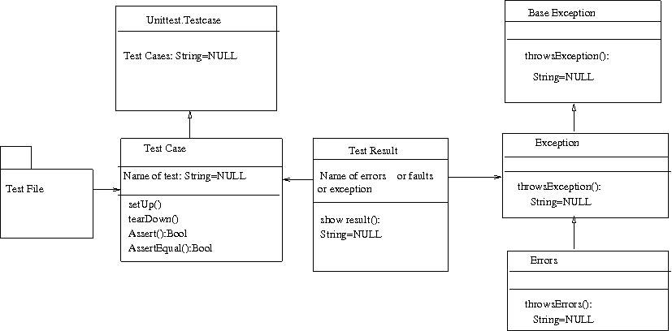

Figure 2.2: Object Model

